INTE 12213– Object Oriented Programming

Lab Exercises 02

You are given the following tasks. Perform all of them.

You have to use a text editor and the terminal in order to complete the below tasks and you are not permitted to use an IDE.

Prepare a report with the experiment, your observations on each task and conclusions. Submit the files by 11.59 pm on the lab session day to the CAL.

No marks will be given to any late submissions.

(Try to use Linux environment)

# Lab02_Task01

Given the following class, called NumberHolder, write some code that creates an instance of the class, initializes its two member variables, and then displays the value of each member variable.

public class NumberHolder {

public int anInt;

public float aFloat;

}

# Lab02_Task02

Write a very simple but complete class. The class represents a counter that counts 0, 1, 2, 3, 4,....

* The name of the class should be Counter.
* It has one private instance variable representing the value of the counter.
* It has two instance methods:
  + increment() adds one to the counter value, and
  + getValue() returns the current counter value.

Write a complete definition for the class, Counter.

# Lab02_Task03

Modify class Account (Fig. 1) to provide a method called debit that withdraws money from an Account. Ensure that the debit amount does not exceed the Account’s balance. If it does, the balance should be left unchanged and the method should print a message indicating "Debit amount exceeded account balance." Modify class AccountTest (Fig. 2) to test method debit.

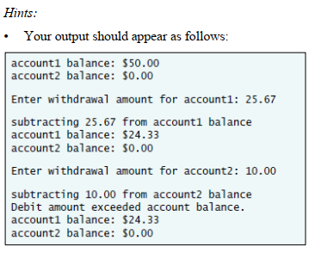

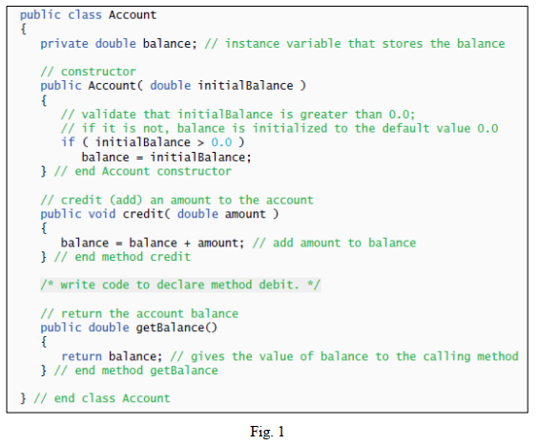

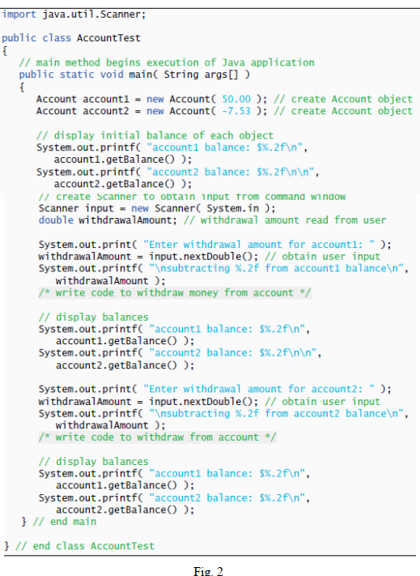

# Lab02_Task04

Modify class GradeBook (Fig. 3). Include a second String instance variable that represents the name of the course’s instructor. Provide a set method to change the instructor’s name and a get method to retrieve it. Modify the constructor to specify two parameter one for the course name and one for the instructor’s name. Modify method displayMessage such that it first outputs the welcome message and course name, then outputs "This course is presented by: " followed by the instructor’s name. Modify the test application (Fig. 4) to demonstrate the class’s new capabilities.

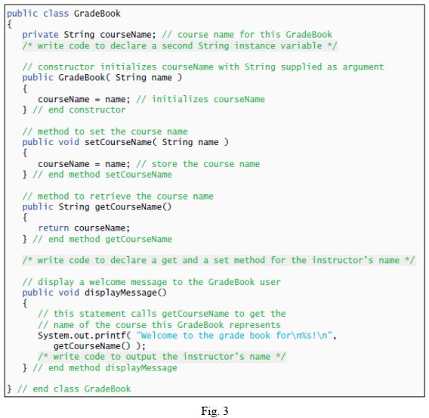

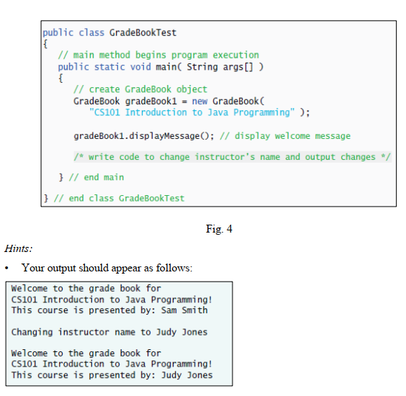

# Lab02_Task05

Create a class called Employee that includes three pieces of information as instance variables—a first name (type String), a last name (type String) and a monthly salary (type double). Your class should have a constructor that initializes the three instance variables. Provide a set and a get method for each instance variable. If the monthly salary is not positive, set it to 0.0. Write a test application named EmployeeTest that demonstrates class Employee’s capabilities. Create two Employee objects and display the yearly salary for each Employee. Then give each Employee a 10% raise and display each Employee’s yearly salary again.

# Lab03_Task06

Write an application that computes the total ticket sales of a concert. There are three types of seatings: A, B, and C. the program accepts the number of tickets sold and the price of a ticket for each of the three types of seats. The total sales are computed as

totalSales = numberOfA_Seats * pricePerA_Seat +

numberOfB_Seats * pricePerB_Seat +

numberOfC_Seats * pricePerC_Seat ;

Write this application using an instantiable SeatType class. An instance of the SeatType class keeps track of the ticket price for a given type of seat (A, B, or C) and the number of tickets sold for each seat type. (Hint: Create objects called seatA, seatB, and seatC to track the sales).